1. Creating and Renaming Files/Directories
Create a directory named test_dir using mkdir.
Inside test_dir, create an empty file called example.txt.
Rename example.txt to renamed_example.txt using mv
Creating and Renaming Files/Directories
Commands:
mkdir test_dir
cd test_dir
touch example.txt
mv example.txt renamed_example.txt
Explanation:
- mkdir test_dir → Creates a new directory named test_dir
- cd test_dir → Moves into that directory
- touch example.txt → Creates an empty file
• • mv example.txt renamed_example.txt → Renames the file
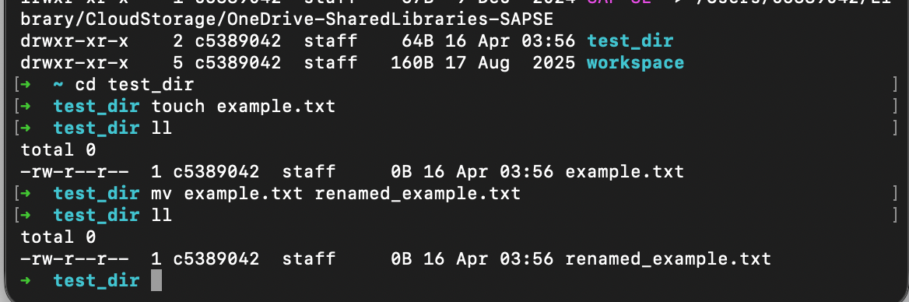

2. Viewing File Contents
Use cat to display the contents of /etc/passwd.
Display only the first 5 lines of /etc/passwd using head.
Display only the last 5 lines of /etc/passwd using tail.
Viewing File Contents
Commands:
cat /etc/passwd
head -n 5 /etc/passwd
tail -n 5 /etc/passwd
Explanation:
- cat → Displays full file content
- head -n 5 → Shows first 5 lines
• • tail -n 5 → Shows last 5 lines
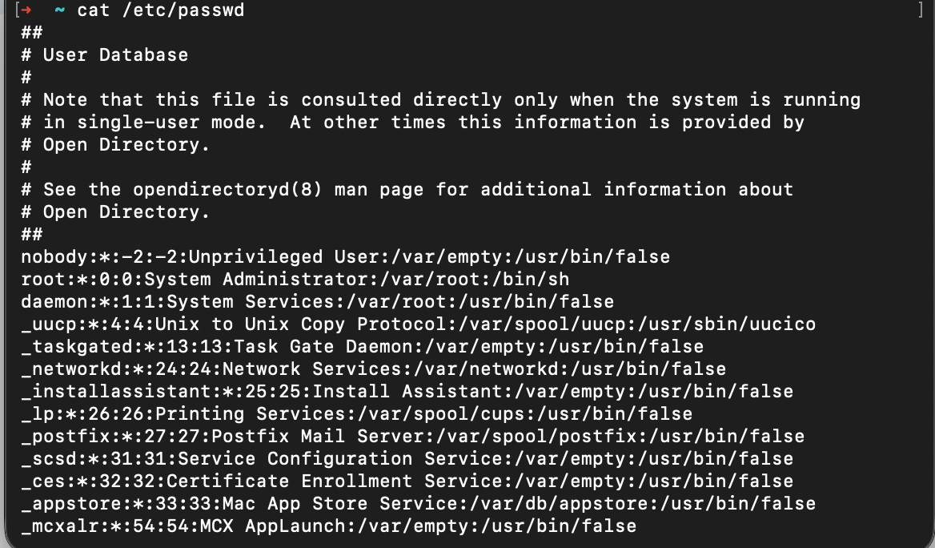
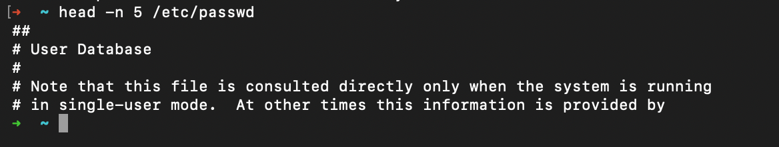
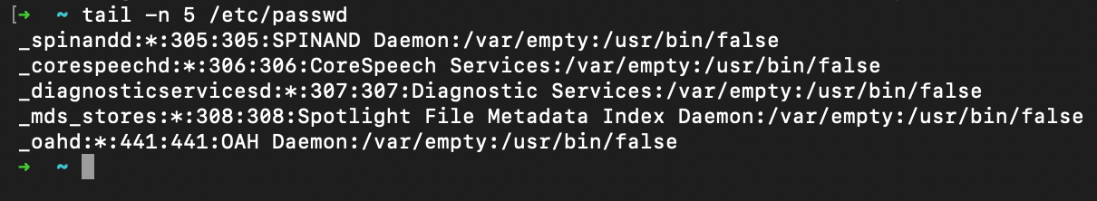
3.Searching for Patterns
Use grep to find all lines containing the word "root" in /etc/passwd.

Searching for Patterns
Command:
grep "root" /etc/passwd
Explanation:
- grep "root" → Finds all lines containing the word root
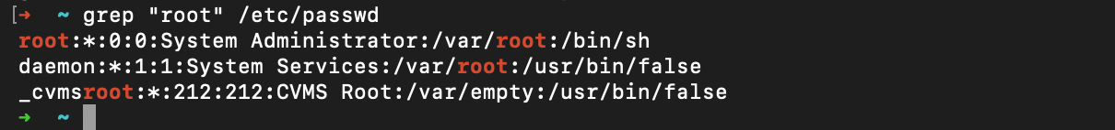

4. Zipping and Unzipping
Compress the test_dir directory into a file named test_dir.zip using zip.
Unzip test_dir.zip into a new directory named unzipped_dir.

Zipping and Unzipping
Commands:
zip -r test_dir.zip test_dir
unzip test_dir.zip -d unzipped_dir
Explanation:
- zip -r → Compresses directory recursively
- unzip ... -d → Extracts files into a specified directory
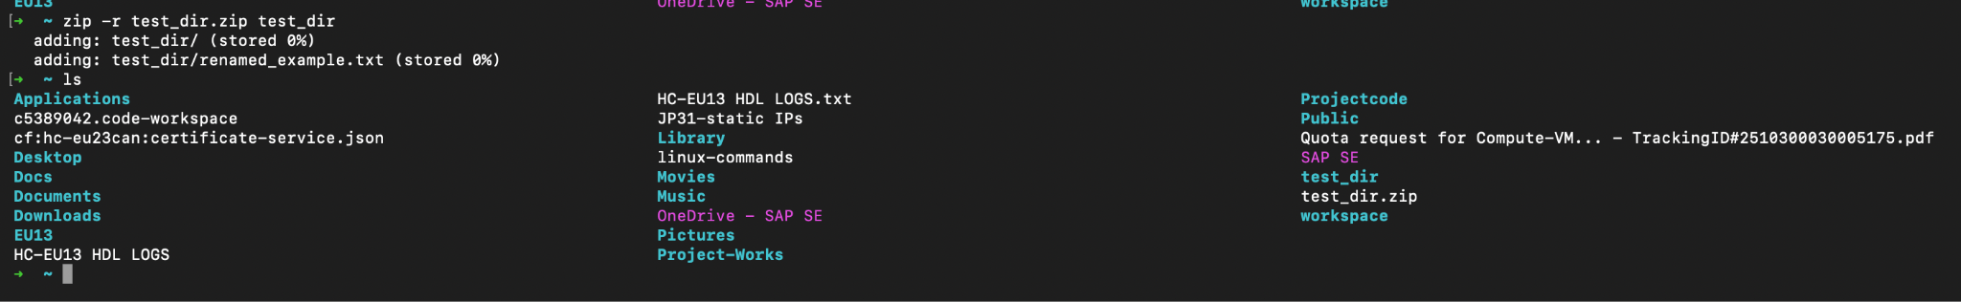
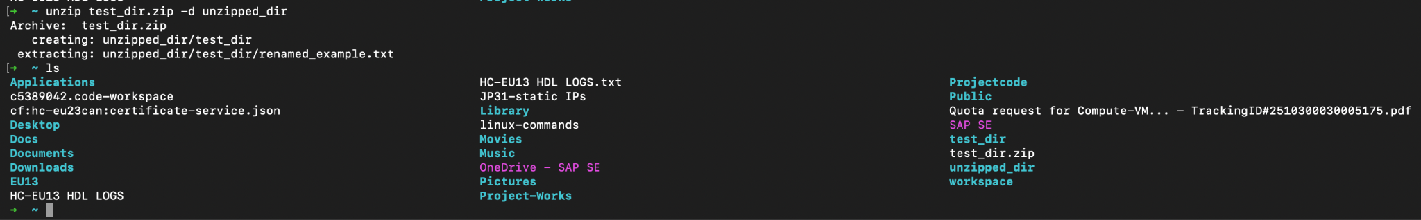

5. Downloading Files
Use wget to download a file from a URL (e.g., https://example.com/sample.txt).

Downloading Files
Command:
wget https://example.com/sample.txt
Explanation:
- wget → Downloads file from a URL to your current directory
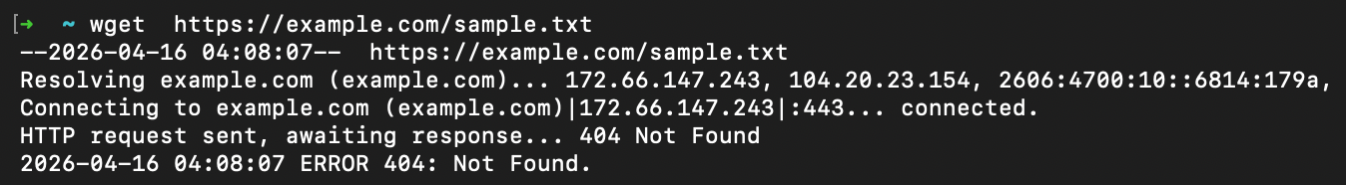

6. Changing Permissions
Create a file named secure.txt and change its permissions to read-only for everyone using chmod.

Changing Permissions
Commands:
touch secure.txt
chmod 444 secure.txt
Explanation:
- touch secure.txt → Creates file
- chmod 444 → Sets read-only permission for:
  - owner
  - group
  - others
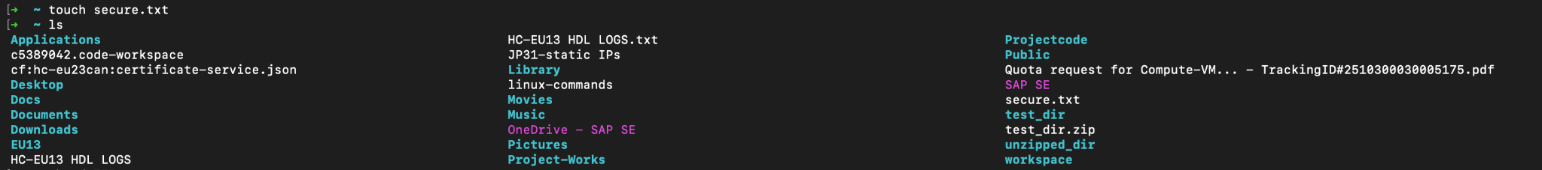
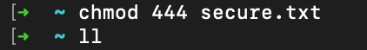
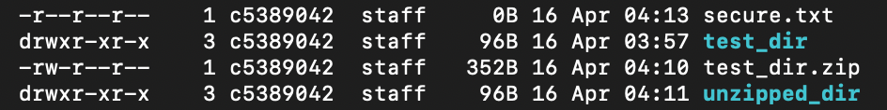

7. Working with Environment Variables
Use export to set a new environment variable called MY_VAR with the value "Hello, Linux!".

Working with Environment Variables
Command:
export MY_VAR="Hello, Linux!"
Explanation:
- export → Creates an environment variable
- MY_VAR → Variable name
- "Hello, Linux!" → Assigned value
